**What is Spring MVC?**

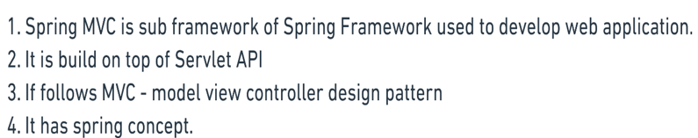

**What is architecture of Spring MVC?**

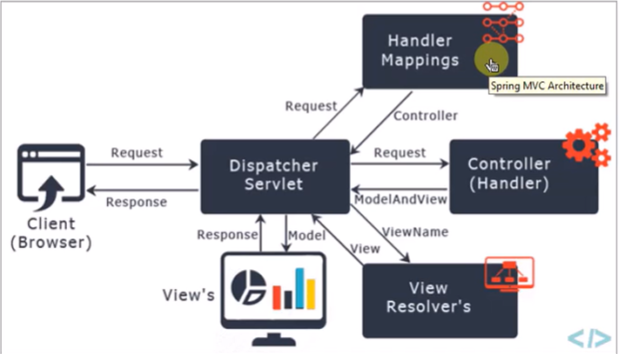

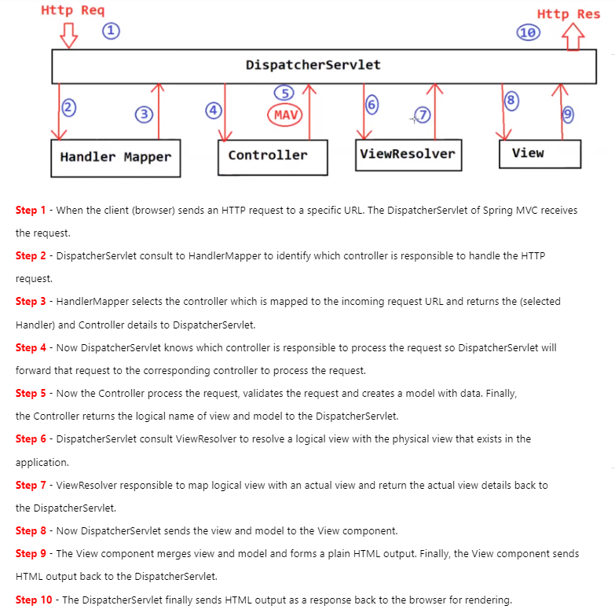

**What are steps follow to use spring MVC?**

* **1. Set dispatcher servlet in web.xml**

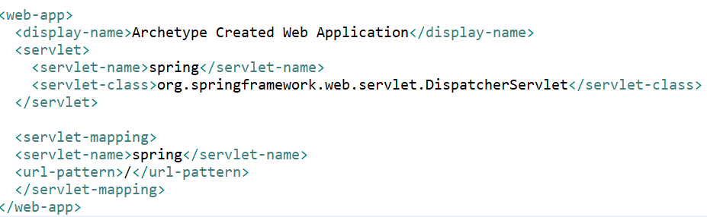

* **2. Make spring-servlet config xml and config view resolver**

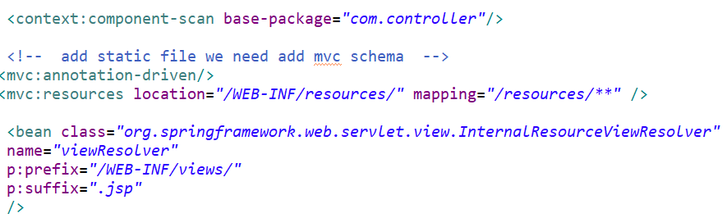

* **3. Create controller and create view to show**

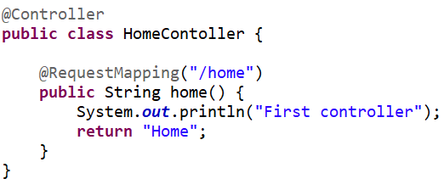 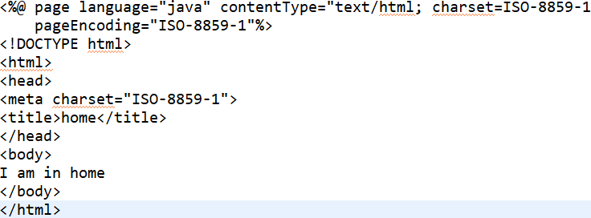

**What all annotation we used in Spring MVC?**

1. @Controller: It used make class as controller which take care of request mapping to view and business logic also.

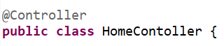

1. @RequestMapping: It is used to map your http request to handler method of MVC like GET, POST,PUT..

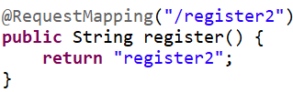 

1. @RequestParam - It is used to bind your web request parameter to method parameter.

It takes all parameter from your view to controller.

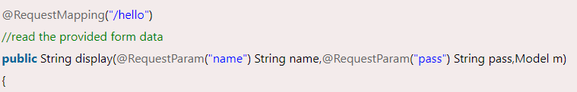

1. @ModelAttribute annotation - one of the most important annotations in Spring MVC. It binds a method parameter or a method return value to a named model attribute and then exposes it to a web view

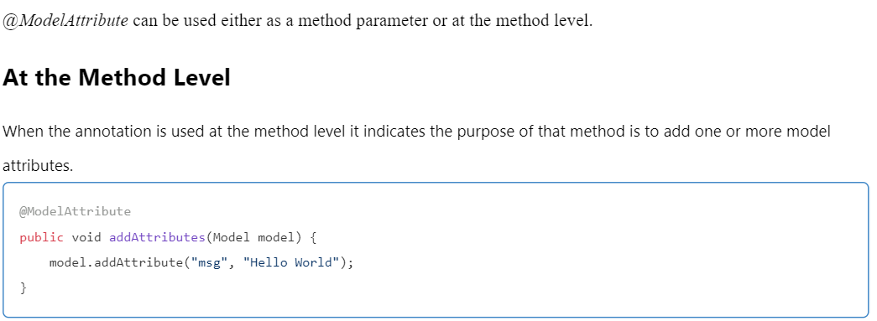

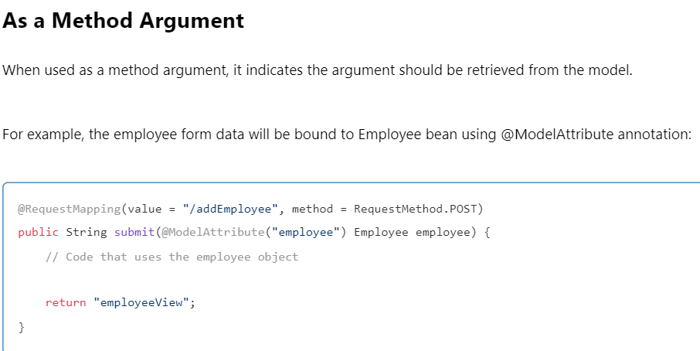

Without Model Attribute problems: use Model OR Model And View

* You need to set all data of your model
* You need to set model name as well

It all done by @ModelAttribute itself.

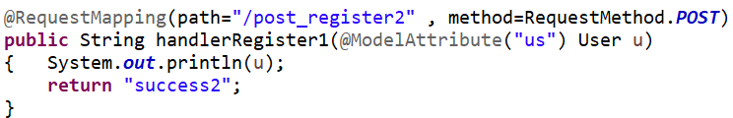 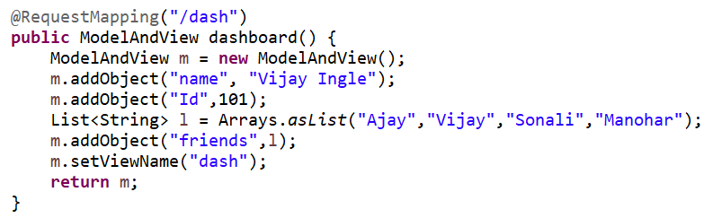

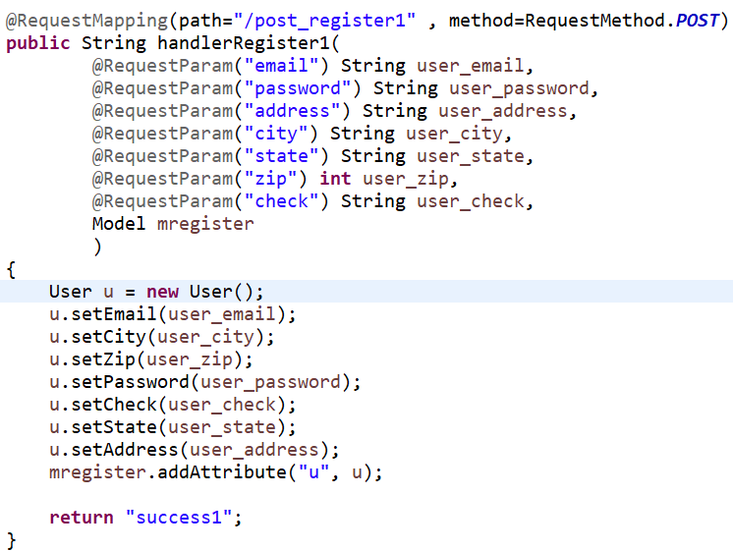

1. @Service - It will say your class is act as service class
2. @Repository - It will say your class is act as DAO layer
3. @PathVariable - used to bind method parameter and URL template variable

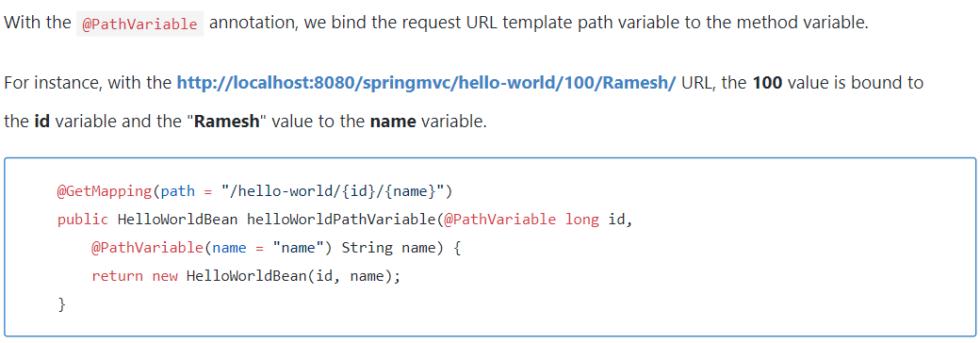

**What is @Responsebody & @Requestbody in Spring MVC?**

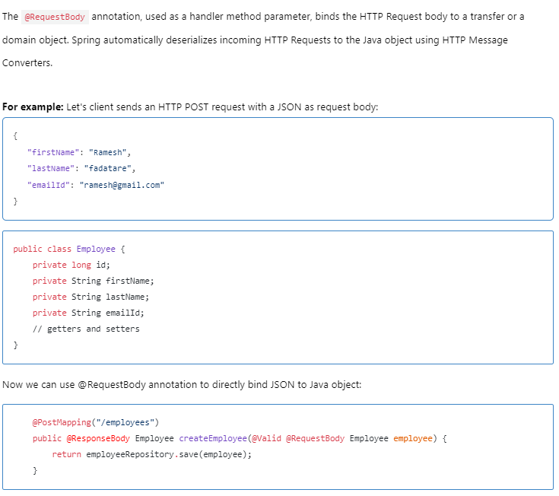

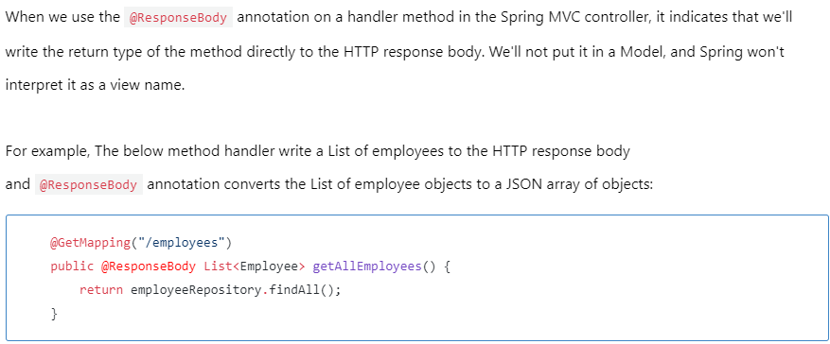

**How to you handle exception in Spring MVC?**

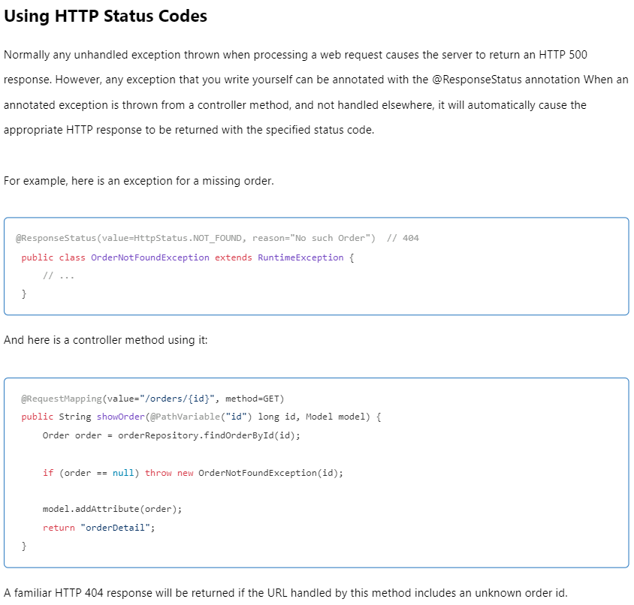

**Using Controller based exception:**

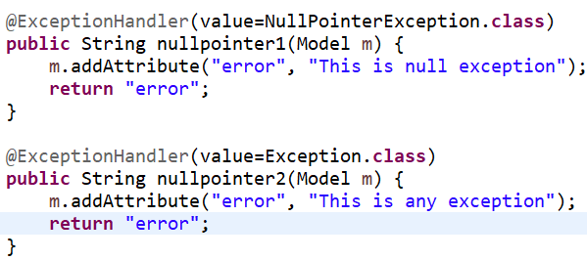



**Using Global Exception handling:**

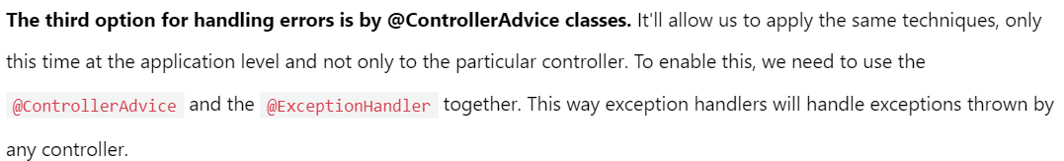

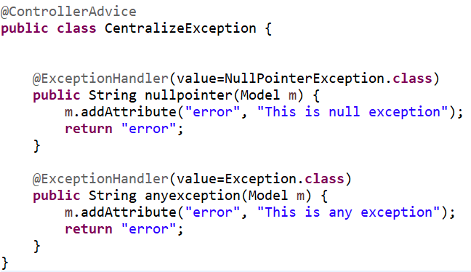

**What are the ways to redirect one view to other?**

* Using Redirect Prefix & Using Redirect View:

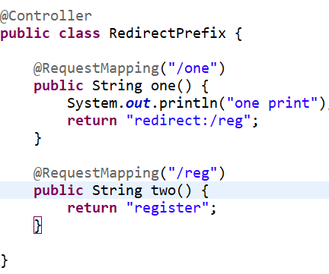 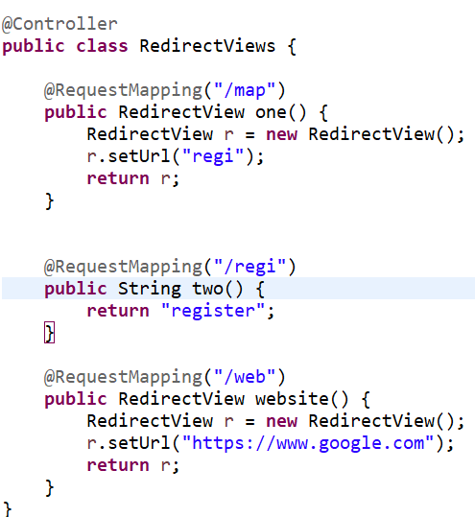

**What is Binding Result in spring mvc?**

It is used when we are doing validation of models

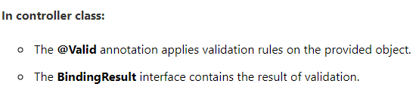

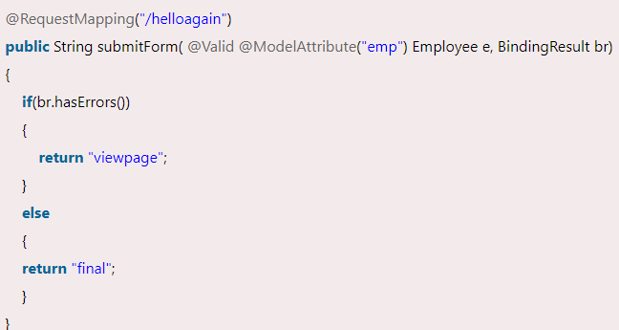 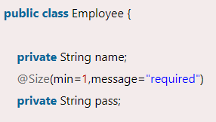

**Note :**

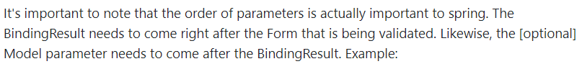

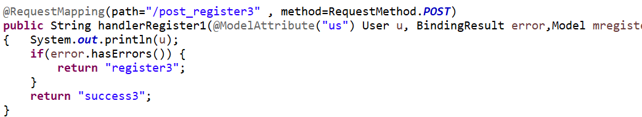

**What is Spring Interceptor & how to configure it?**

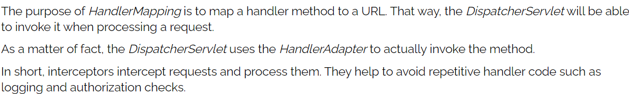

* In spring-servlet.xml

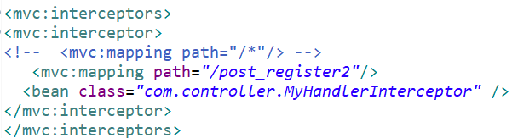

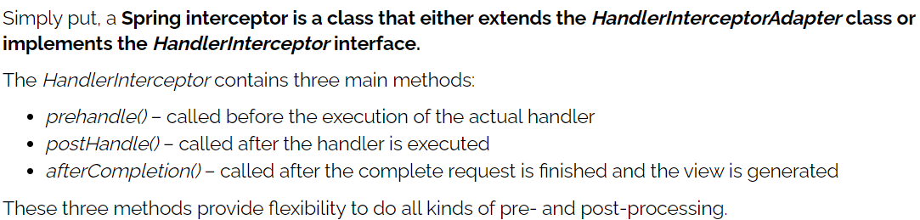

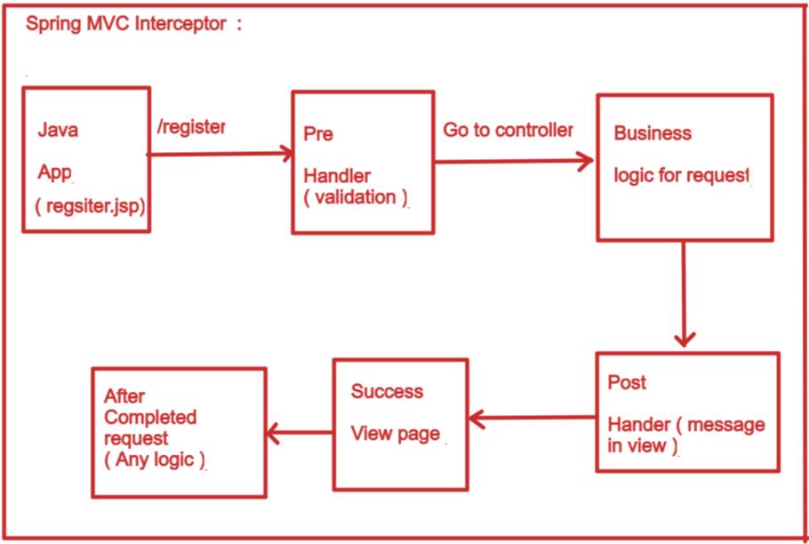

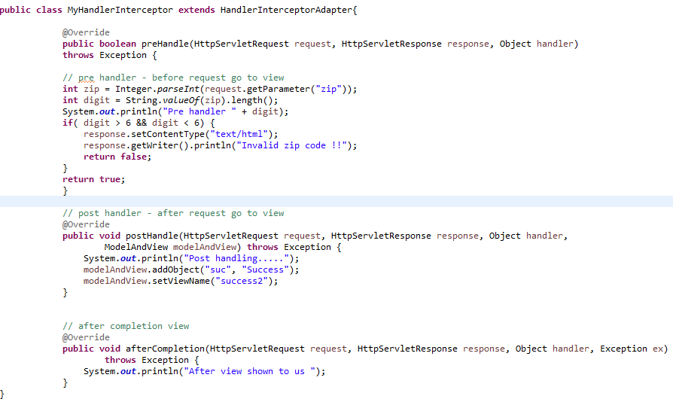

**What is MVC?**

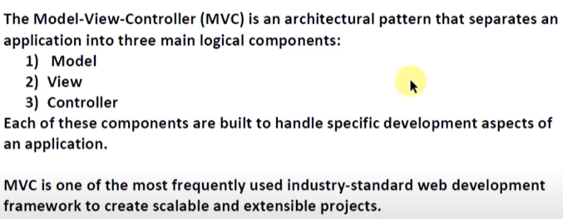

**What are new features added ins spring 5?**

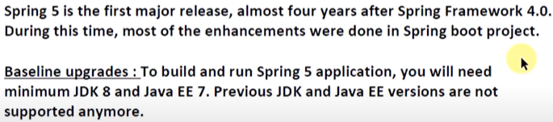

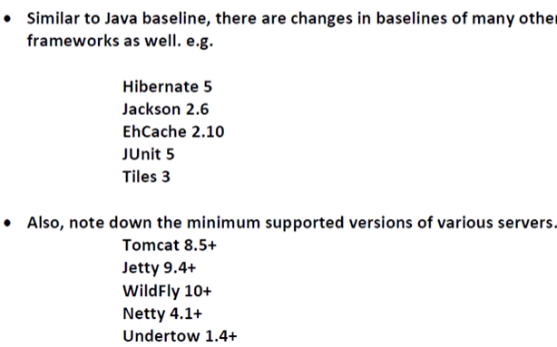

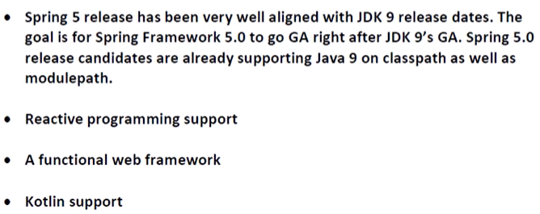

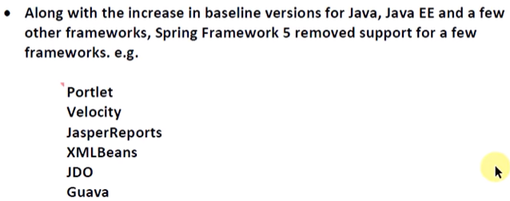

**What are all patterns followed by spring?**

